Author
Shivani Vishwakarma
Roll number: 23f3002814
Email: 23f3002814@ds.study.iitm.ac.in
I am a data science student at IIT Madras. This is my first multi-user web app project, giving hands-on web development experience.
Description
Vehicle Parking App V1 manages 4-wheeler parking lots with admin and user roles. Admins manage lots and users can register, reserve spots, and view booking history. Parking times and billing are automated.
AI tools were used during the development of the project to assist with frontend design (HTML/CSS), database schema planning, and debugging errors encountered in Flask and SQLAlchemy. Additionally, AI helped in drafting the README file for clear documentation. While AI supported these tasks, all suggestions were manually reviewed and adapted to fit the project requirements. Overall, the estimated AI/LLM contribution was around 8%.
Technologies Used
- Python, Flask, Flask-SQLAlchemy: Backend and ORM
- Jinja2: HTML templating
- SQLite: database
- Bootstrap: Responsive UI
- Chart.js: Data visualization

Database schema design:
The app uses four tables: users, parking_lots, parking_spots, and booking_history.
Key relationships:
- One user → many bookings
- One lot → many spots and bookings
- One spot → many bookings over time
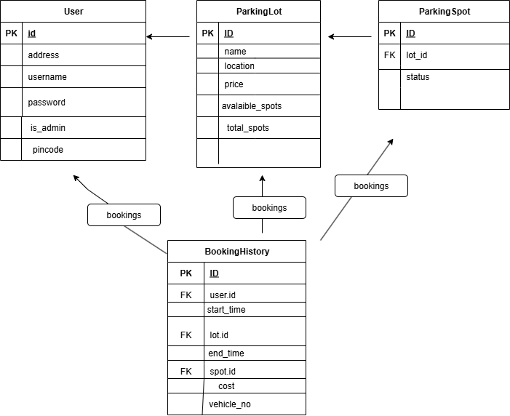

API Design:
APIs were created using Flask routes with GET and POST methods to support user and admin operations.
- Authentication:
POST /login, POST /register for login and user registration.
- User APIs:
GET /dashboard – View lots and booking history
POST /reserve/<lot_id> – Auto-assign and reserve a spot
POST /release/<booking_id> – End booking and calculate cost
GET /summary – View total hours parked and money spent
- Admin APIs:
GET /admin_dashboard, POST /admin/add_lot, POST /edit_lot/<lot_id>, GET /delete_lot/<lot_id> – Manage lots
GET /view_spots/<lot_id> – View spot status
GET /admin_users, GET /admin/dashboard/summary – View users and system report
Flask sessions handle user state. Parameters like lot_id and booking_id are passed in URLs. Validation prevents double bookings and deletion of active lots.

Architecture and Features
Project organized into
- main.py (routes),
- database.py (models),
- templates (Jinja2 HTML),
- static (CSS/images).
Features include user/admin authentication, parking spot auto-assignment, booking history, billing, and admin reporting with charts.
Features Implemented
The app supports two roles: Admin and User. Default features include user registration/login, admin dashboard, parking lot creation, and spot booking. Users can view available lots, reserve the available spot, release bookings, and view summaries (hours parked and total cost). Admins can add/edit/delete lots, view spot status, registered users, and total earnings.
Additional features include automatic spot assignment, prevention of double booking, parking time tracking using timestamps, and interactive charts using Chart.js for summaries.

Demo video link: https://drive.google.com/file/d/1X_QyTrYjisKsPdC5pmUB3fIed3wHNjZi/view?usp=drive_link

